

Tribhuvan University
Faculty of Humanities and Social Science

REAL TIME CHAT APP
A PROJECT REPORT

Submitted to
Department of Computer Application
Padmakanya Multiple Campus

In partial fulfillment of the requirements for the Bachelor in Computer Application

Submitted By
Rabina Sapkota
Registration no: 6-2-38-692-2020
Symbol No: 3802043

Under the Supervision of
Basanta Chapagain

TRIBHUWAN UNIVERSITY
Faculty of Humanities and Social Science
Padmakanya Multiple Campus
Bagbazar, Kathmandu, Nepal

LETTER OF APPROVAL

This is to certify that this project prepared by Rabina Sapkota entitled “Real Time Chat App” in partial fulfillment of the requirements for the degree of Bachelor in Computer Application has been evaluated. In our opinion it is satisfactory in the scope and quality as a project for the required degree.
……………………….
Signature of Coordinator
ER. Kumar Prasun
Padmakanya Multiple Campus
….…………………………
Signature of External Supervisor
……………………………
Signature of Supervisor
Basanta Chapagain
PadmaKanya Multiple Campus
….…………………………….
Signature of Internal Supervisor

TRIBHUWAN UNIVERSITY
Faculty of Humanities and Social Science
Padmakanya Multiple Campus

SUPERVISOR’S RECOMMENDATION

The Project entitled “Real Time Chat App” Proposed by Rabina Sapkota for the Partial Fulfillment of the requirement for Bachelor in Computer Application (BCA), Eight semester has been approved for further development.

………………………….
SIGNATURE
Basanta Chapagain
Supervisor
PadmaKanya Multiple Campus
Bagbazar ,Kathmandu

ACKNOWLEDGEMENT
I would like to extend my heartfelt appreciation and gratitude to the Department of Bachelor of Computer Applications (BCA) at Padma Kanya Multiple Campus, affiliated with Tribhuvan University. This project would not have been possible without the invaluable opportunity provided to us by the university and the department as a part of our academic curriculum.
I owe a special debt of gratitude to our dedicated supervisor Mr. Basanta Chapagain. His consistent support, invaluable guidance, encouragement have been vital in steering this project towards its successful completion and I am deeply grateful for his contributions.
I would also like to express thanks to Padma Kanya Multiple Campus for providing with the necessary resources and ideal environment for the development of this project.
I would also like to share our gratitude to Tribhuvan University for providing the opportunity to evaluate our programming skill through this project.

Sincerely,
Rabina Sapkota

ABSTRACT
A real-time chat application is a web-based platform that enables instant communication between users, supporting text messages. The application provides user authentication, allowing only registered users to send and receive messages, while unregistered users can access features. Users can search for contacts or messages, and view online/offline status of friends. Real-time message delivery is implemented using WebSockets, ensuring low latency and seamless communication. The system also maintains message history, and seen/delivery status for enhanced user experience. Developed using Python Django as the backend framework, with HTML, CSS, and JavaScript for the frontend, this application provides a secure, scalable, and interactive platform for instant messaging. The system design ensures efficient handling of multiple concurrent users while maintaining data security and privacy.
Keywords: Real-Time Chat Application, Python Django, WebSockets, HTML, CSS, JavaScript.

Table of Contents
LETTER OF APPROVAL I
SUPERVISOR’S RECOMMENDATION II
ACKNOWLEDGEMENT III
ABSTRACT IV
LIST OF FIGURES VII
LIST OF TABLES VIII
LIST OF ABBREVIATIONS IX
AES Advance Encryption Standard IX
CHAPTER-1 1
INTRODUCTION 1
1.1 Introduction 1
1.2 Problem Statement 1
1.3 Objective 2
1.4 Scope 2
1.5 Limitation 2
1.6 Developed Methodology 2
1.6 Report Organization 3
CHAPTER-2 5
BACKGROUND STUDY AND LITERATURE REVIEW 5
2.1 Background Study 5
2.2 Literature Review 5
CHAPTER-3 7
SYSTEM ANALYSIS AND DESIGN 7
3.1 System Analysis 7
3.1.1 Requirement Analysis 7
3.1.2 Feasibility Analysis 9
3.1.3 Object Modelling: Class & Object Diagram 11
3.1.4 Dynamic Modelling: State and Sequence Diagram 13
3.1.5 Process Modelling: Activity Diagram 15
3.2 System Design 17
3.2.1 Component Diagram 18
3.3 Algorithm Details 19
CHAPTER-4 24
IMPLEMENTATION AND TESTING 24
4.1 Implementation 24
4.2 Implementation Details of Modules 25
4.3. Testing 26
4.3.1 Test Cases for Unit Testing 26
CHAPTER 5 30
CONCLUSION AND FUTURE RECOMMENDATION 30
5.1. CONCLUSION 30
5.2 Lesson Learnt 30
5.3 Future Recommendations 30
REFERENCES 32
APPENDIX

LIST OF FIGURES
Figure 1.6 Iterative Waterfall Model…………………………………………………………3 Figure 3.1.1: Use case diagram of Real Time Chat App………………….…………………...8 Fig 3.1.2: Gantt Chart of Real Time Chat App…………………………………………….10 Fig 3.1.3: Class Diagram of Real Time Chat App…………………………………..……..12 Figure 3.1.4.1: State Diagram of Real Time Chat App…………………………………….13 Fig 3.1.4.2: Sequence Diagram of Real Time Chat App……………………………………..14 Fig 3.1.5: Activity Diagram of Real Time Chat App…………….…………………….…….16 Fig 3.2: System design of Real Time Chat App……………………….……………………..17 Fig3.2.1: Component diagram of Real Time Chat App……………………….………….....18

LIST OF TABLES
Table 4.3.1: Real Time Chat App User Login………………………………………………..26 Table 4.3.2: Real Time Chat App Admin Login…………………………………………..…26 Table 4.3.3: Real Time chat App for User Registration……………………………..……….27 Table 4.3.4: Chat History of Real time chat App………………………………………….…27 Table 4.3.5: Admin Manages of Real Time Chat App……………………….……………….28

LIST OF ABBREVIATIONS
AES Advance Encryption Standard
API Application Programming Interface
BCA Bachelor in Computer Application
DB Database
OOP Object Oriented Programming
PY Python
UI User Interface

CHAPTER-1

INTRODUCTION

1.1 Introduction
In today's fast-paced digital world, real-time communication is essential for enhancing collaboration, customer engagement, and user experience. This project proposes the development of a Real-Time Chat Application that enables instant messaging between users with seamless interaction, reliability, and responsiveness. The application utilize modern web technologies and algorithms such as, AES , Boyer-Moore String Matching algorithm, Python to support chat functionality with features like user authentication, message history, and typing indicators.
Designed for scalability and cross-platform compatibility, this chat application serve as a robust communication tool for personal, educational, or organizational use. By focusing on a user-friendly interface and secure communication channels, the project demonstrate key principles of full-stack development, real-time data handling, and efficient design.

1.2 Problem Statement
In an increasingly connected world, the need for fast, efficient, and reliable communication platforms has become critical. Traditional messaging systems often suffer from latency, poor scalability, and limited real-time capabilities, which can hinder effective communication in both personal and professional environments. Moreover, many existing chat solutions are either too complex for small-scale use or lack customization features required by specific user groups.
There is a growing demand for a lightweight, secure, and easy-to-use real-time chat application that supports instant messaging, group chats, presence indicators, and message synchronization across devices. This project aims to address these challenges by developing a real-time communication platform that ensures low-latency data transmission, robust user authentication, and a responsive user interface tailored to modern usage needs.

1.3 Objective
The main objectives of this project are: -
- Develop a real-time messaging system using WebSockets.
- Implement secure user authentication and authorization by using AES algorithm

1.4 Scope
• Real-time text messaging
• One-to-one chat support
• User registration and login
• User profiles
• Responsive UI for mobile/desktop

1.5 Limitation
• Requires internet connection
• Slow networks can delay messages
• Server may lag with too many users/messages
• Limited storage for large chats or files
• Vulnerable to security issues if not coded properly

1.6 Developed Methodology
The Iterative Waterfall model was selected as the project's chosen approach because of the complete understanding of all the requirements and regarding the necessary algorithm at the project's outset. This system is designed with the series of processes starting with the requirement gathering and analysis, design, coding and testing and maintenance.

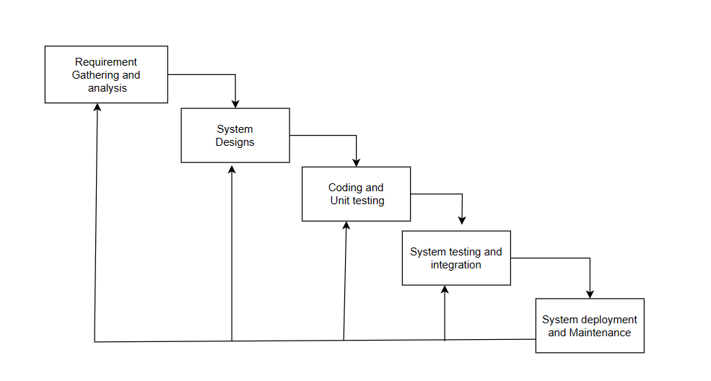
Figure 1.6 Iterative Waterfall Model

1.6 Report Organization
Introduction
This chapter deals with the introduction, problem statement, objectives, scopes and limitations of the system.
Background Study and Literature Review
This chapter includes the brief description of the work that has been carried out in making Real Time Chat App and also describes the features about some existing applications related to Chat Applications.
System Analysis and Design
Here, all the system analysis and design component are included. Different software requirements i.e., functional and non-functional requirement and various feasibility study are also encompassed in this system analysis part. In addition, class: object diagram, sequence diagram, activity diagram and flowchart are also included.
Implementation and Testing
This chapter includes the description of tools that are used in system development.
Further this chapter also includes the result of testing performed in the system development.
Conclusion and Future Recommendation
This chapter contains the lesson learned in the system development process, system outcome and conclusion are noted here. Likewise, the future recommendation and enhancement part from the developer perspective are also listed under this chapter.

CHAPTER-2

BACKGROUND STUDY AND LITERATURE REVIEW

2.1 Background Study
The Chat Application is designed to enable seamless real-time communication between users within a digital platform. As communication becomes increasingly digital, chat systems play a crucial role in connecting individuals for personal, academic, and professional purposes. The primary objective of the chat application is to provide users with an efficient, user-friendly environment where they can send and receive messages instantly.
To achieve this, the system incorporates essential functionalities such as user authentication, message delivery, message status indicators, and friend management. Modern chat applications rely on various technologies including WebSockets, encryption techniques, and optimized algorithms (like Boyer–Moore for message search). These technologies ensure fast message transmission, improved system response, and secure user interactions.
Furthermore, features such as real-time updates, multimedia sharing enhance user satisfaction by offering a more interactive communication experience. Concepts like online presence, notification systems, and data storage strategies also play significant roles in determining how effectively the application handles user engagement.
Overall, the background of the chat application is rooted in the need for efficient digital communication, leveraging modern web technologies to provide a smooth, secure, and dynamic messaging experience.

2.2 Literature Review
In 2016, the International Conference on Engineering and Technology published ”Designing and implementing a real-time web-based chat server” by Diotra Henriyan, Devie Pratama Subiyanti, and Rizki Fauzian (ICSET). According to this study report, a chat application should have a live forum and be multi-site to accommodate a large user base. The programming language is used to create the MongoDB website and the Node.js server with a clear foundation.[1]
The chat application is something that allows users to get in touch directly. People can interact using this online application. People can interact using this online application effectively even far apart. To be utilized by many people, this web-based application is supposed to be real-time and multiplatform. Chatterbox is a real-time chat application developed using MERN stack development thus it is easily extendible and developed with recent technologies. Also, it has features like voice calls, video calls, screen sharing, chatting, and much more for users in one application.[2]
R. Gayathri, C. Kalieswari published their work in 2020 in the International Journal of Engineering and Advanced Technology (IJEAT) . The chat application offers a better and more adaptable programme for debate, according to this research article.Developed with cutting-edge technologies to offer a dependable system. The system’s primary benefits include group chat, improved security, real-world collaboration, and instant messaging. For the majority of businesses looking to have private applications, this app may locate the greatest market demand. Based on community requests, more programme features like conference calls and video chat will also be implemented.[3]
The Internet provides a cheap and convenient way to explore and communicate with distant people. A multitude of services have converged on the smartphone platform, and potentially the most notable is social networking. With increased interconnectivity and use of online services, concerns about consumers’ security and privacy are growing. In this paper, it evaluate the security- and privacy-preserving features provided by existing mobile chat services.[4]

CHAPTER-3

SYSTEM ANALYSIS AND DESIGN

3.1 System Analysis
System analysis is conducted for the purpose of studying a system or its parts in order to identify its objectives. It is a problem solving technique that improves the system and ensures that all the components of the system work efficiently to accomplish their purpose. This system is designed with series of processes starting with requirement gathering and analysis, design, coding and testing and maintenance. During requirement analysis, all the functional and not functional requirement are analyzed and system is developed according to the requirement then designing of the system is carried out. After the design process, coding process, coding and development part is started then after unit testing followed by integrating the system and the testing of the system. If the testing is positive, then system is implemented otherwise some maintenance is done and again testing is done until system come in operation.

3.1.1 Requirement Analysis
Requirement analysis plays a key role. Requirement analysis is not only important for the project, but it is also important for the project management function. For the project, understanding what the project will eventually deliver is critical for its success. Through requirements, the project management can determine the end deliveries of the project and how the end deliveries should address client's specific requirements.
I. Functional Requirements
The major functional requirements of this system are as follows:
a. User roles
- User can sign up by providing required information.
- User can sign in to the system using their email and password.
- User can manage their contacts and groups.
- User can exchange real-time messages (including viewing history) in private chats.
b. Admin roles
- Admin can manage user accounts (e.g.,add,modify, delete).
- Admin handles user queries and resolves technical issues.
- Admin can monitor real-time activity and generate reports.
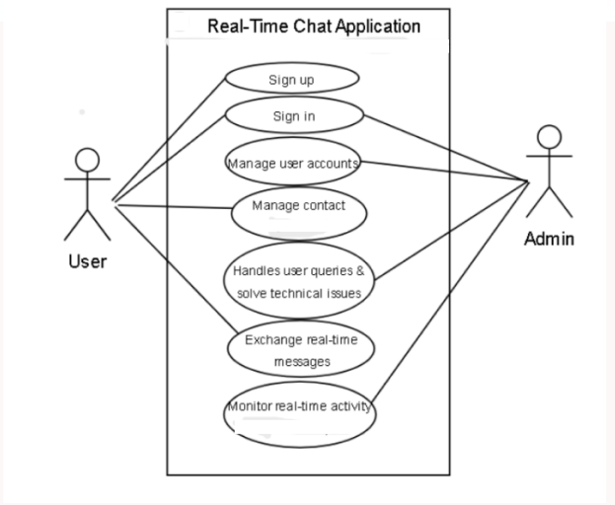
Figure 3.1.1: Use case diagram of Real Time Chat App

II. Non-Functional Requirements
A non-functional requirement is a requirement that specifies criteria that can be used to judge the operation of a system, rather than specific behaviors. Non-functional requirements are "constraints", "quality attributes", "quality goals", "quality" of service requirements" and "non-behavioral requirements". The plan for implementing non-functional requirements is detailed in the system architecture.
Some non-functional requirements of the project are listed below:
- User Friendly:
The chat app has an easy-to-use interface, simple registration, and smooth navigation to accommodate all users.
- Efficiency:
It loads chats and contacts quickly and delivers messages promptly for a seamless experience.
- Security:
Data is protected with encryption during transmission and strong password hashing to keep user information safe.
- Performance:
Messages are sent and received in real-time, typically within 500 milliseconds under normal conditions.
- Scalability:
The system can grow to support more users and messages without slowing down or crashing.
- Maintainability:
Code is organized and documented clearly, making it easier to update and manage in the future.

3.1.2 Feasibility Analysis
The Real-Time Chat Application is technically and practically feasible because users with basic computer or smartphone knowledge can easily operate the system. The development process does not require expensive tools or advanced hardware, making the system suitable for academic and practical implementation. The feasibility study is categorized as follows:
I. Technical Feasibility
This includes the study of the technical tools that will be used to built the system and by the user to use this system and that tools are effective enough or not to use this system. After technical feasibility study, our research leads to the conclusion that following devices are efficient and effective to built the system and the user to use our system.
PC with minimum Pentium IV processor or latest processor
4GB RAM or above
40GB Hard Disk or above
Mobile phone which can run on internet and consist of Google Chrome
Stable internet connection for real-time communication
Open-source tools such as VS Code, PostgreSQL, Python, and Django.
II. Operational Feasibility
All the research about the functionality of the software whether it will gives the results as we expected or not are done in this. All the functionality such as registering the user, user login to the system, database stability for the system, user control by the admin user, etc are examined whether it is operationally possible or not in this system. We have referenced this system and found out that it is possible to fulfill all the functionality of this system.
III. Economic Feasibility
It is economically feasible because it is developed using open-source tools. No any paid version of software and professional developers are used to build the project. No any other hardware resource is required except PC.
IV. Schedule Feasibility
The project is completed and achieved under a deadline according to strategy. It is developed within time limit. Hence, it is feasible in respective schedule.
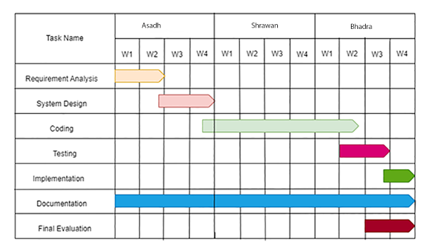
Fig 3.1.2: Gantt Chart of Real Time Chat App

3.1.3 Object Modelling: Class & Object Diagram
The object modelling for the real-time chat application explains the structural and behavioral relationships between the major classes involved in the system. The UML class diagram consists of five primary classes: User, Chat, Message, and Notification. Each class contains specific attributes and methods that define its role within the system. The diagram also shows how these classes interact through different types of relationships such as aggregation, association, and inheritance.
The User class represents individual users of the chat system. It maintains attributes such as user_id, username, email, and password. It also defines behaviors such as register(), login(), logout(), sendMessage(), and receiveMessage().
The Admin class extends the User class through inheritance. Admin shares the core user attributes and methods but provides additional functionalities, such as manageUsers() and viewReports(), which are essential for system-level administration.
The Message class represents the chat messages exchanged between users. It includes attributes such as message_id, sender, receiver, timestamp, and content, along with behaviors such as encryptMessage(), decryptMessage(), and deliver(). A User can send multiple messages, and each message is associated with one sender and one receiver, forming a one-to-many association.
The Chat class manages one-to-one chat sessions between users. It aggregates multiple messages, meaning that the Chat cannot function without messages, but messages can exist independently. It includes attributes such as chat_id, participants, and last_active, and methods such as startChat(), loadMessages(), and updateStatus().
The Notification class provides real-time updates to users about new messages, typing indicators, or user status. It includes notification_id, type, message_reference, and is_read attributes. Users can receive many notifications, forming another one-to-many association.
Overall, the UML class diagram clearly presents the modular structure of the chat system. It highlights how classes interact through associations, aggregations, and inheritance to support real-time communication, message management, group chats, and notification handling. This structured representation provides an effective blueprint for implementing the system and ensuring that all functionalities operate seamlessly.
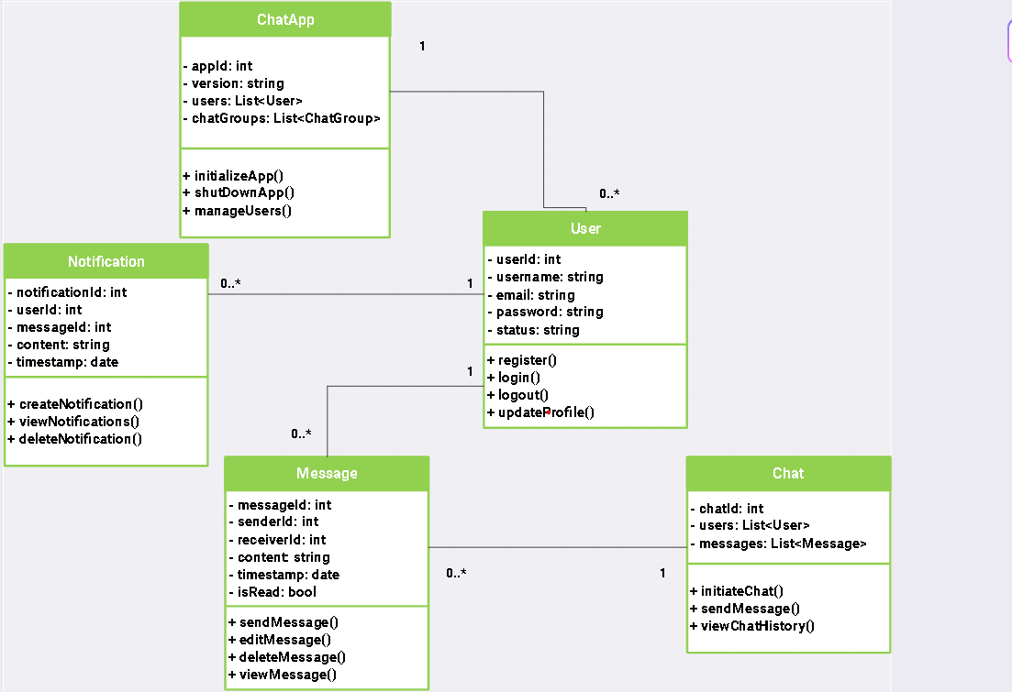
Fig 3.1.3: Class Diagram of Real Time Chat App

3.1.4 Dynamic Modelling: State and Sequence Diagram
State Diagram:
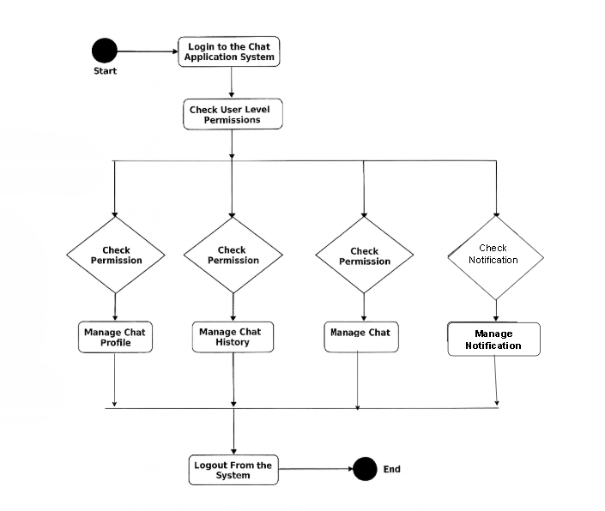
Figure 3.1.4.1: State Diagram of Real Time Chat App
The state diagram represents the entire workflow of a user interacting with a real-time chat application. The process begins at the initial state, represented by a solid black dot, where the user must first create an account through the Registration state. During registration, the user enters their personal details such as username, email, and password. Once the registration is successfully completed, indicated by the condition “Registration Successful”, the system transitions to the Verification state. If the email, credential are correct and the verification is successful, shown by the condition “Verification Successful”, the user moves to the Login state.
In the Login state, the user provides their authenticated credentials (username/email and password). Upon entering valid information, the condition “Login Successful” is triggered, and the user is transferred to the User Dashboard state.
Inside the User Dashboard, the user is presented with multiple options. They can view a list of available chats, view unread messages, and initiate or continue conversations.
Sequence Diagram:
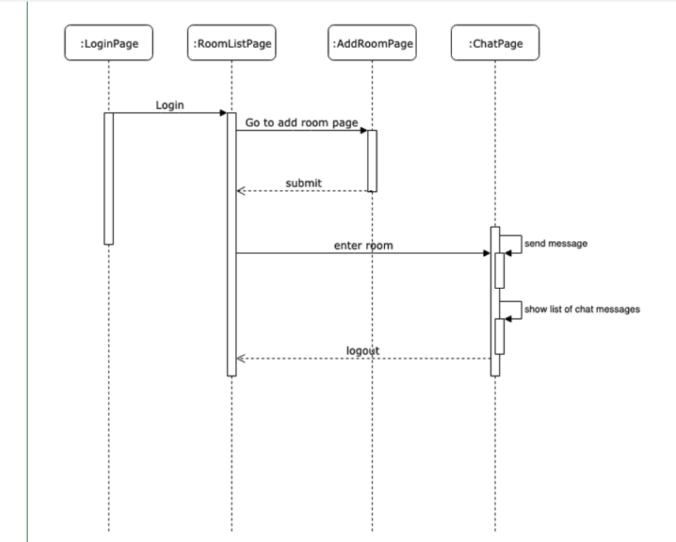
Fig 3.1.4.2: Sequence Diagram of Real Time Chat App
The sequence diagram represents the interactions between a user and the real-time chat application, showing the chronological order of messages and actions. The process begins with the User object, which initiates a request to the System to register an account. During the Registration interaction, the user provides their personal details, such as username, email, and password. The system validates the input and responds with a Registration Successful message if all information is correct.
Following successful registration, the System sends a Verification Request to the user’s email. The User completes the verification by clicking the verification link, and the system responds with a Verification Successful confirmation. Once verified, the User sends a Login Request with credentials (username/email and password) to the system. Upon validation, the system responds with Login Successful, granting access to the User Dashboard.
Inside the User Dashboard, the user can perform multiple actions. They can send a Fetch Chat List request to the system, which returns the list of available chats. The user can select a chat and send Send Message requests, to which the system responds with Message Delivered or Message Seen updates. For real-time communication, the system also continuously sends Receive Message notifications for incoming messages, ensuring that the user’s chat view is updated dynamically without requiring page reloads.
Additional interactions include Logout Request, which ends the session and returns the user to the initial state. Throughout the sequence, the system ensures proper authentication, verification, and message delivery to maintain a secure and responsive chat experience.

3.1.5 Process Modelling: Activity Diagram
The activity diagram represents the workflow of a user interacting with a real-time chat application. The process begins with a black dot, indicating the initial state or start of the application.
For a new user, the first process is Registration, represented by a rectangle with rounded corners. During registration, the user enters personal information such as username, email, and password. Upon successful registration, the user is redirected to the Login process. Returning users skip directly to the login process.
During Login, the system verifies the user credentials. If the credentials are correct, the user is redirected to their User Dashboard, where they can access the main features of the chat application. If the credentials are incorrect, the system redirects the user back to the login page to retry.

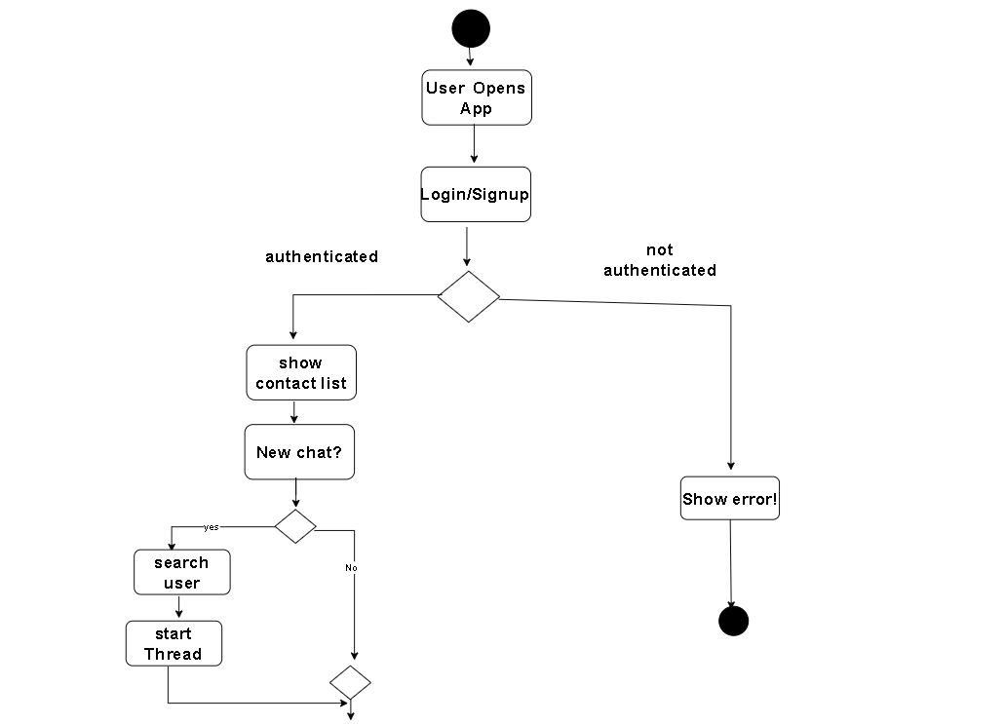
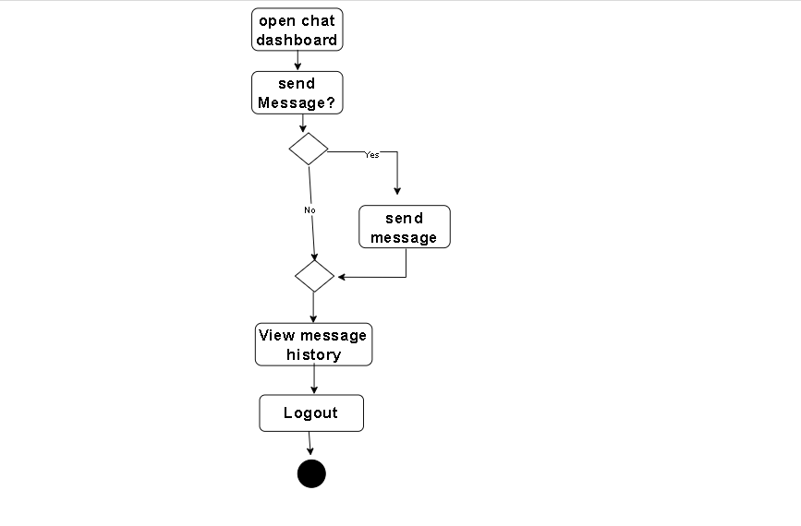
Fig 3.1.5: Activity Diagram of Real Time Chat App

3.2 System Design
The system design of a real-time chat application is based on a client-server architecture that enables instant communication between users. The client side handles the user interface, allowing users to view contacts, send and receive messages, join group chats, share files, and update profiles, while receiving real-time updates via WebSockets . The server side manages authentication, user sessions, message storage, and real-time broadcasting, as well as administrative tasks like user and group management. A database layer stores users, messages, groups, and media files efficiently, supporting quick retrieval of chat history. The real-time communication layer ensures low-latency message delivery, and security measures like authentication, HTTPS, and end-to-end encryption protect user data. The system is designed for scalability with load balancing, caching, and support for multiple concurrent connections, while additional features such as notifications, presence indicators, and message status enhance the user experience, making the application secure, responsive, and manageable for both users and administrators.
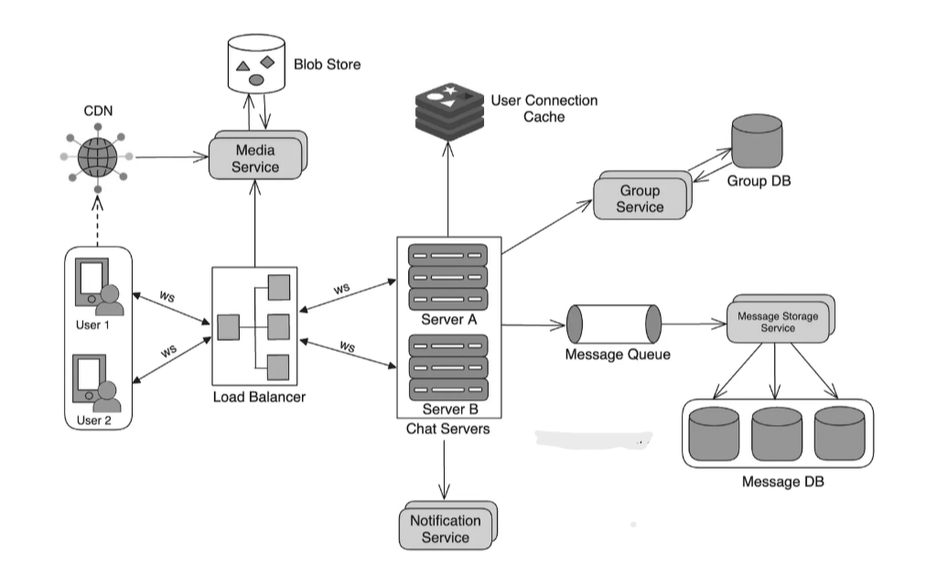
Fig 3.2: System design of Real Time Chat App

3.2.1 Component Diagram
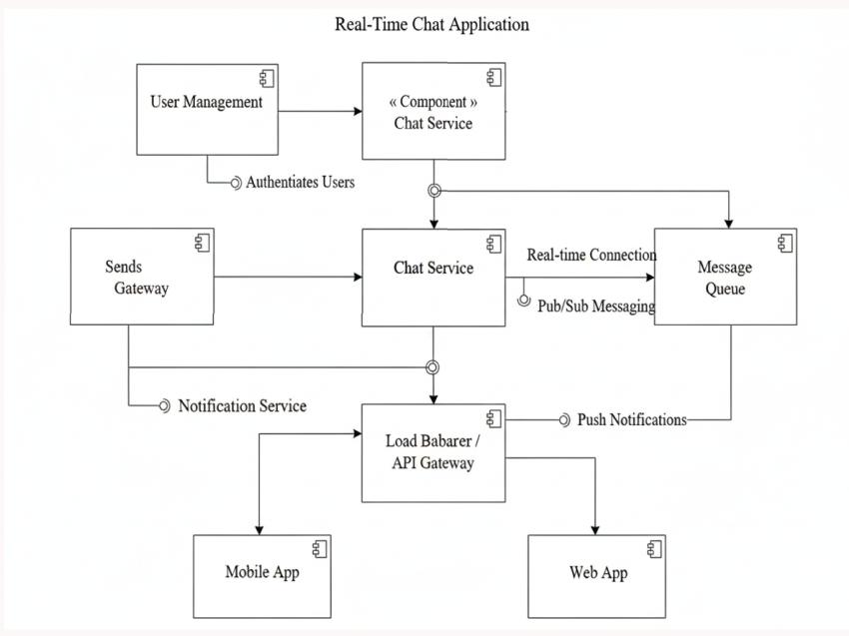
Fig3.2.1: Component diagram of Real Time Chat App
Component Diagram that outlines the high-level architecture of a Real-Time Chat Application. It shows the main, self-contained, modular pieces (components) of the system and how they interact. Key components include the Client Application (what the user sees, likely mobile or web), the Chat Server/Engine (the core backend logic handling message routing and user presence), a dedicated WebSocket Server (crucial for maintaining persistent, bidirectional connections necessary for real-time low-latency messaging), the Database (for storing user data and chat history), and the Authentication/Security Service (for user login and access control). These components communicate via defined interfaces (like API calls and WebSocket connections) to deliver instant messaging functionality.

3.3 Algorithm Details
1.AES (Advanced Encryption Standard)
Advanced Encryption Standard (AES) is a highly trusted encryption algorithm used to secure data by converting it into an unreadable format without the proper key. It is developed by the National Institute of Standards and Technology (NIST) in 2001.AES encryption uses various key lengths (128, 192, or 256 bits) to provide strong protection against unauthorized access. This data security measure is efficient and widely implemented in securing internet communication, protecting sensitive data, and encrypting files. AES, a cornerstone of modern cryptography, is recognized globally for its ability to keep information safe from cyber threats.
- AES is a Block Cipher.
- The key size can be 128/192/256 bits.
- Encrypts data in blocks of 128 bits each.
AES performs operations on bytes of data rather than in bits. Since the block size is 128 bits, the cipher processes 128 bits (16 bytes) of the input data at a time.
The number of rounds depends on the key length as follows:
Number of Rounds (N) | Key Size(in bits)
10 | 128
12 | 192
14 | 256

Mathematical Basis:
AES operates on a 128-bit block of data using substitution-permutation network (SPN) principles. Each round includes:
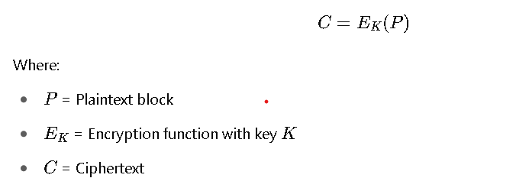
Encryption
AES considers each block as a 16-byte (4 byte x 4 byte = 128 ) grid in a column-major arrangement.
Step1. Substitute Bytes (Sub)
This step implements the substitution.
In this step, each byte is substituted by another byte. It is performed using a lookup table also called the S-box. This substitution is done in a way that a byte is never substituted by itself and also not substituted by another byte which is a compliment of the current byte. The result of this step is a 16-byte (4 x 4 ) matrix like before.
Step2. Shift Rows
This step is just as it sounds. Each row is shifted a particular number of times.
- The first row is not shifted
- The second row is shifted once to the left.
- The third row is shifted twice to the left.
- The fourth row is shifted thrice to the left.
(A left circular shift is performed.)
[ b0 | b1 | b2 | b3 ] [ b0 | b1 | b2 | b3 ]
| b4 | b5 | b6 | b7 | -> | b5 | b6 | b7 | b4 |
| b8 | b9 | b10 | b11 | | b10 | b11 | b8 | b9 |
[ b12 | b13 | b14 | b15 ] [ b15 | b12 | b13 | b14 ]
Step 3: Mix Columns
This step is a matrix multiplication. Each column is multiplied with a specific matrix and thus the position of each byte in the column is changed as a result.
Step 4: Add Round Keys
- Now the resultant output of the previous stage is XOR-ed with the corresponding round key. Here, the 16 bytes are not considered as a grid but just as 128 bits of data.
- After all these rounds 128 bits of encrypted data are given back as output. This process is repeated until all the data to be encrypted undergoes this process.
Decryption
The stages in the rounds can be easily undone as these stages have an opposite to it which when performed reverts the changes. Each 128 blocks goes through the 10,12 or 14 rounds depending on the key size.
The stages of each round of decryption are as follows :
- Add round key
- Inverse MixColumns
- ShiftRows
- Inverse SubByte
2. Boyer-Moore String Matching Algorithm
The Boyer Moore Algorithm is used to determine whether a given pattern is present within a specified text or not. It follows a backward approach for pattern searching/matching. The task of searching a particular pattern within a given string is known as a pattern searching problem. It is considered as the most efficient and widely used algorithm for pattern matching.
Mathematical Concept:
Boyer-Moore skips characters based on heuristics.
Let:
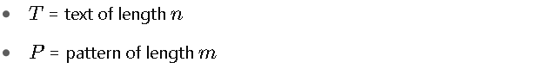
Worst-case time complexity:
- Bad character heuristic : This heuristic uses a table that stores the last occurrence of each character in the pattern. When a mismatch occurs at some character(bad character) in the text, the algorithm checks if this character appears in the pattern. If it does, then it shifts the pattern such that the last occurrence of this character in the pattern aligns with the bad character in the text. If it does not, then it shifts the pattern past the bad character.
- Good suffix heuristic : This heuristic uses another table that stores shift information when the bad heuristic fails. In this case, we look within the pattern till bad character become good suffix of the text. Then we shift onward to find the given pattern.
Example:
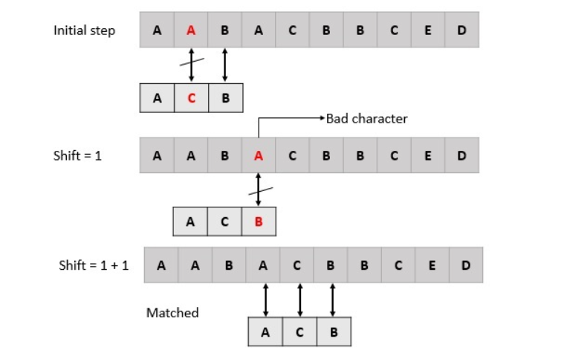
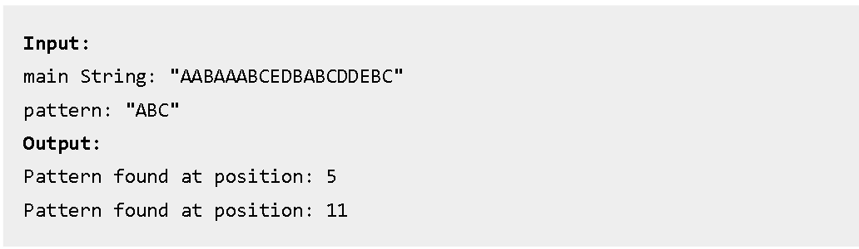

CHAPTER-4

IMPLEMENTATION AND TESTING

4.1 Implementation
For developing the Real-Time Chat Application , the following tools and technologies can be utilized:
- Programming Language:
  - Python: Chosen for its simplicity, extensive libraries, and strong support for network programming and real-time applications.
- Web Framework:
  - Django : To build the backend server that handles user authentication, message routing, and API endpoints.
  - Django offers a full-featured framework with built-in authentication.
- Real-Time Communication:
  - WebSockets with channels (for Django) :
These libraries enable real-time, bi-directional communication between client and server, essential for instant messaging.
- Database:
  - PostgreSQL or SQLite: For storing user data, message history, and chat metadata.
- Frontend Technologies:
  - HTML, CSS, JavaScript to create a responsive and interactive user interface.
- Encryption:
  - PyCryptodome: A Python library to implement AES encryption and decryption for secure message handling.
- Development Environment:
  - VS Code, or any preferred Python IDE for coding and debugging.
  - Git for version control.
Documentation tools:
- Microsoft word
This is used for writing and editing the documentation of Tourism Place Suggestion System.
- Draw.io
This is used to generate diagrams for system analysis and design of system. Diagrams were created using this tool in order to save time since all components are available with drag and drop Functions.

4.2 Implementation Details of Modules
1. User Authentication Module
The User Authentication Module manages user registration, login, logout, and access control. It ensures that only authenticated users can access messaging and other features. Key functions include user registration, password encryption and validation, login verification, and role-based access control for users and administrators.
2. Messaging Module
The Messaging Module enables users to send and receive messages in real-time. It supports text, emojis, files, and images. Messages are saved in the database for history and include delivery and seen status tracking. This module ensures smooth communication between users.
3. User Dashboard Module
The User Dashboard Module provides an interface for users to interact with the chat application. It displays contacts, allows searching for users or messages, shows online/offline status, and enables profile updates, offering a complete user experience.
4. Admin Panel Module
The Admin Panel Module allows administrators to manage users, groups, messages, and system settings. Admins can add, edit, or delete users and groups, monitor messages for inappropriate content, and configure access rights and system-wide settings.
5. Real-Time Communication Module
This module handles instant message delivery and notifications using WebSockets . It establishes connections, broadcasts messages in real-time, triggers notifications, and efficiently manages multiple simultaneous connections.
6. Data Persistence and Database Module
The Data Persistence and Database Module manages the storage and retrieval of all application data. It connects to databases like MySQL or PostgreSQL, stores messages, users, groups, and media, executes queries for chat history, and ensures data integrity and consistency.

4.3. Testing
Testing is a very important phase for any types of software. A software should go through different testing process to ensure that the website is working in the manner in which it was intended to. There are four main stages of testing that need to be completed before a program can be cleared for use: unit testing, integration testing, system testing, and acceptance testing. As this system is not completed as a whole only unit and integrated testing are possible.

4.3.1 Test Cases for Unit Testing
Generally a software constitutes of several different modules and so does this project. A modules or unit can refer to a function, individual program or even a procedure. Here is the list of the test cases.
Table 4.3.1: Real Time Chat App User Login
Test  case | Scenario | Input Value | Expected Output | Actual Output | Remarks
1. | login with correct username and password | User name:rabina  password:rabina123 | Go to dashboard | login successful | PASS
2. | login with incorrect username and password | Username:rabina  password:12345 | Login Unsuccessful | Login Unsuccessful | FAIL

Table 4.3.2: Real Time Chat App Admin Login
Test  case | Scenario | Input Value | Expected Output | Actual Output | Remarks
1. | login with correct username and password | User name:rabina  password:rabina@123 | Goto admin dashboard | login successful | PASS
2. | login with incorrect username and password | Username:rabin  password:12345 | Login Unsuccessful | Login Unsuccessful | FAIL

Table 4.3.3: Real Time chat App for User Registration
Test  case | Scenario | Input Value | Expected Output | Actual Output | Remarks
1. | Register User Details | With all field correctly | Register Successful | Register successful  and Now Login | PASS
2. | Register User Details | Invalid Details | Register Unsuccessful | Register Unsuccessful | FAIL

Table 4.3.4: Chat History of Real time chat App
Test  case |  | Scenario | Input Value | Expected Output | Actual Output | Remarks
1. |  | Launch without opening environment | Django server  http://127.0.0.1:8000/ | Link redirect to webpage | No Connection could be made because target machine actively refused it | FAIL
2. |  | Login with correct details. | Email:rabinasapkota123@  gmail.com  Pw:rabina12 | Login Successfully and go to dashboard. | Login Successful. | PASS
 | 3. | Search users | User=rabinasapkota | Display Rabina Sapkota Profile | Search User name Display | PASS
4. |  | Send message | Message=”hello What’s up” | Displayed | Send Meassage successfully | PASS
5. |  | Receive message | Replied = “All right” | Recived msg Successfully. | Recived message Successfully. | PASS

Table 4.3.5: Admin Manages of Real Time Chat App
Test  case |  | Scenario | Input Value | Expected Output | Actual Output | Remarks
1. |  | Launch withopening Django Server | Django server  http://127.0.0.1:8080 | Link redirect to webpage | Launch successful, redirect to home page | PASS
2. |  | Login as admin | Username:admin  Password:Test@123 | Login Successfully and go to dashboard. | Login Successful. | PASS
 | 3. | Add User | Username :Rabina Sapkota  Pw:rabina12 | Add successfully | Add successfully | PASS
4. |  | Delete User | Username=sunita | Delete  Successful | user name delete | PASS
5. |  | Manage /Edit Users | User name =”Rabin”  Email:rabin@gmail.com  Pw:rabin12  Reenter Pw:rabin12 | Successfully  Manage | Managed Successfully. | PASS

CHAPTER 5

CONCLUSION AND FUTURE RECOMMENDATION

5.1. CONCLUSION
The project, named "Real-Time Chat Application", is a web-based platform designed to facilitate instant communication between users through text, multimedia, and group conversations. It allows users to connect seamlessly, send and receive messages in real-time, share files and images, and manage group chats efficiently. The flexible design ensures easy future enhancements, enabling administrators to manage users, groups, messages, and system settings as needed. This system provides a secure, interactive, and user-friendly environment for communication, improving collaboration and connectivity. The successful completion of the project, which involved integrating essential functionalities such as real-time messaging using WebSockets, user authentication, and multimedia support, has strengthened practical programming skills and translated theoretical knowledge into real-world application development experience.

5.2 Lesson Learnt
With the completion of the project, it has been able to boost academic knowledge and bring it to real practice. Throughout the project, experience was gained working both individually and collaboratively to solve complex problems, improving problem-solving skills. The use and implementation of web-based application development and its implementation was acquired.
After development of the project there are various lesson that we learnt
- Learn how to do system analysis and feasibility study with proper planning.
- Learn full cycle of project development.
- Learn to integrate the system UI with database.

5.3 Future Recommendations
There is always room for improvement in any software or system, no matter how efficient it is. The Real-Time Chat Application has been designed with flexibility in mind, allowing for future enhancements and modifications. The system can be further improved by integrating additional features such as voice and video calling, message encryption for enhanced security, chatbot assistance, file sharing with larger size support, and push notifications for offline users. Other enhancements could include advanced search and filtering, emoji and sticker packs, chat themes and customization options, and analytics for admin to monitor usage patterns. Implementing these features will enhance user experience, increase engagement, and make the chat application more comprehensive and interactive.

REFERENCES
[1] D. Henriyan, D. P. Subiyanti, R. Fauzian, D. Anggraini, M. V. Ghani Aziz, and A. S. Prihatmanto, "Design and Implementation of Web Based Real Time Chat Interfacing Server," 2016. [Unpublished]
[2] N. Zala, J. Fiaidhi, and V. Agrawal, "ChatterBox—A Real Time Chat Application," 2023. [Unpublished]
[3] R. Gayathri and C. Kalieswari, "Multi-User Chatting Application," International Journal of Engineering and Advanced Technology (IJEAT), vol. 9, no. 5, pp. , June 2020.
[4] T. Dodds, "Reporting with WhatsApp: Mobile chat applications’ impact on journalistic practices," Digital journalism, vol. 7, no. 6, pp. 725–745, 2019.

APPENDIX
- Admin homepage:
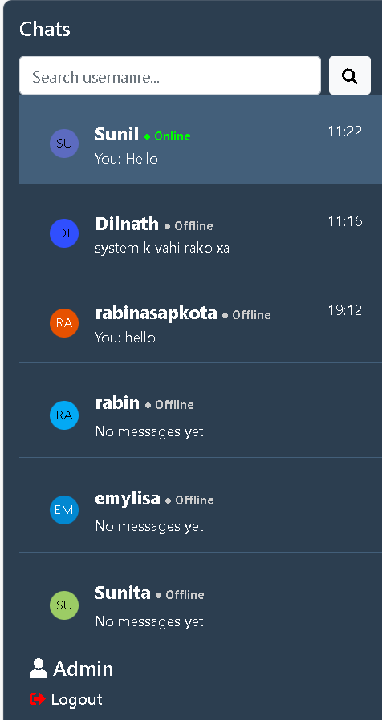
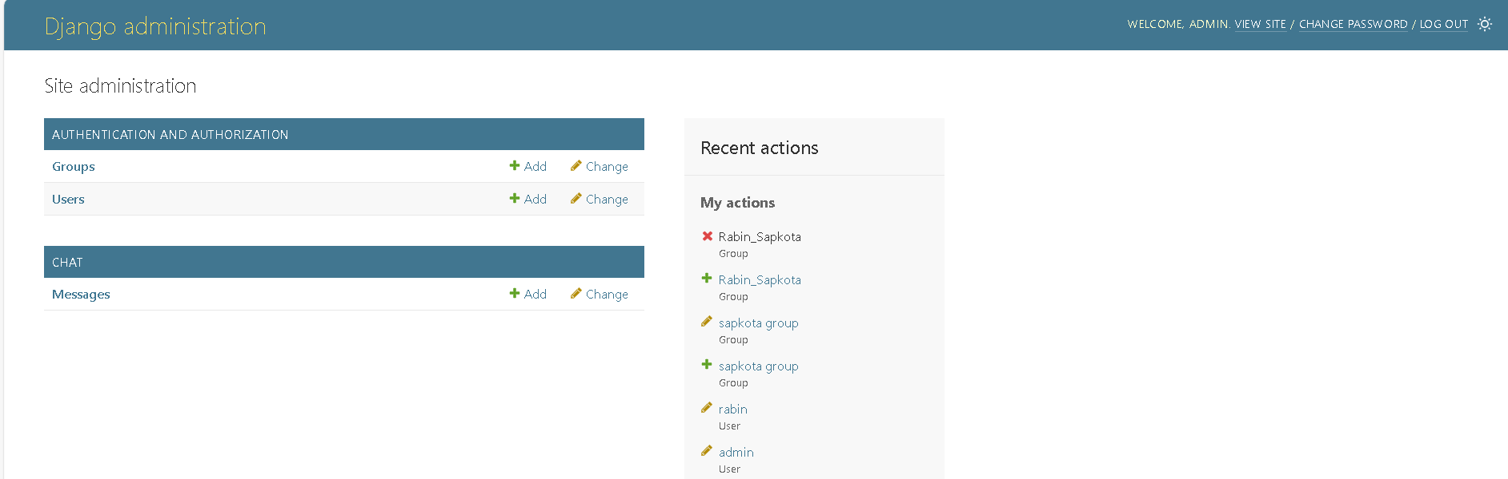
- Admin Dashboard :

- Add user:
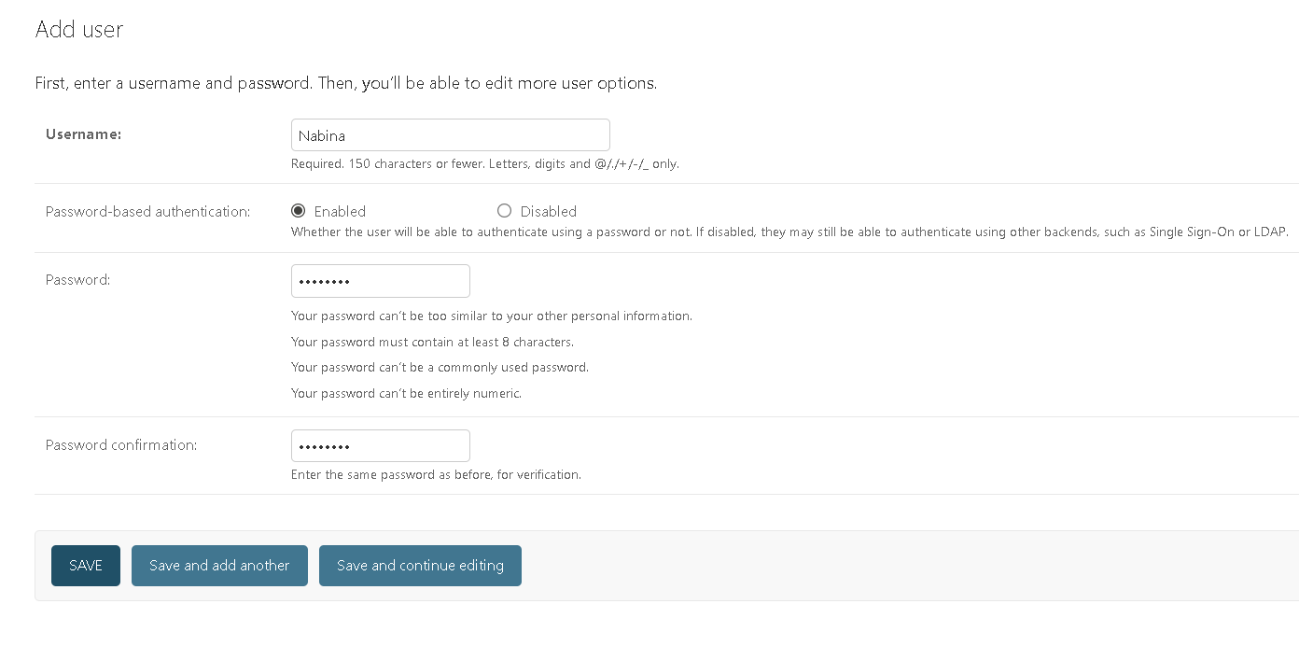
- Delete user by admin 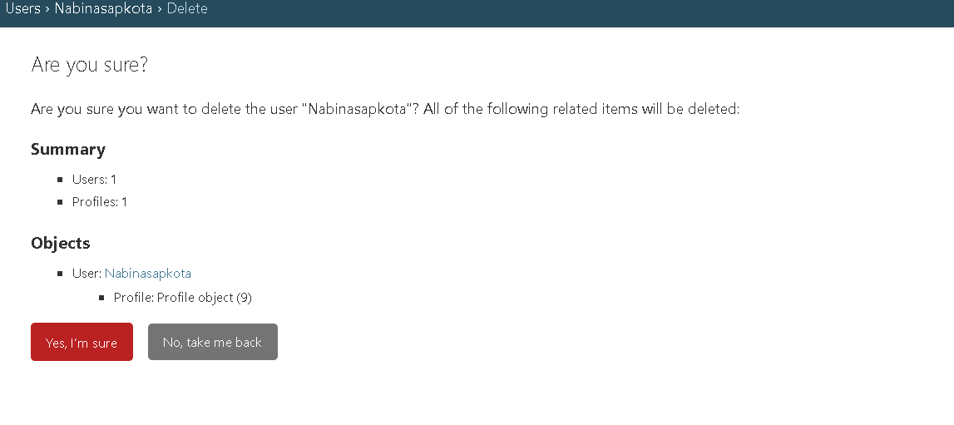

- Message list:
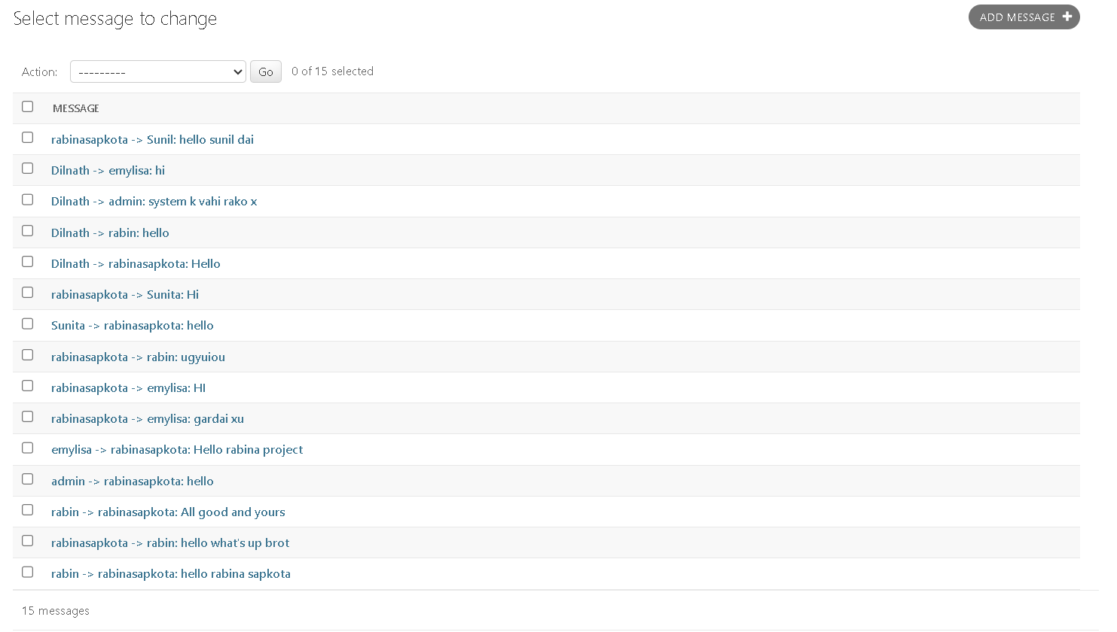
- User Dashboard:
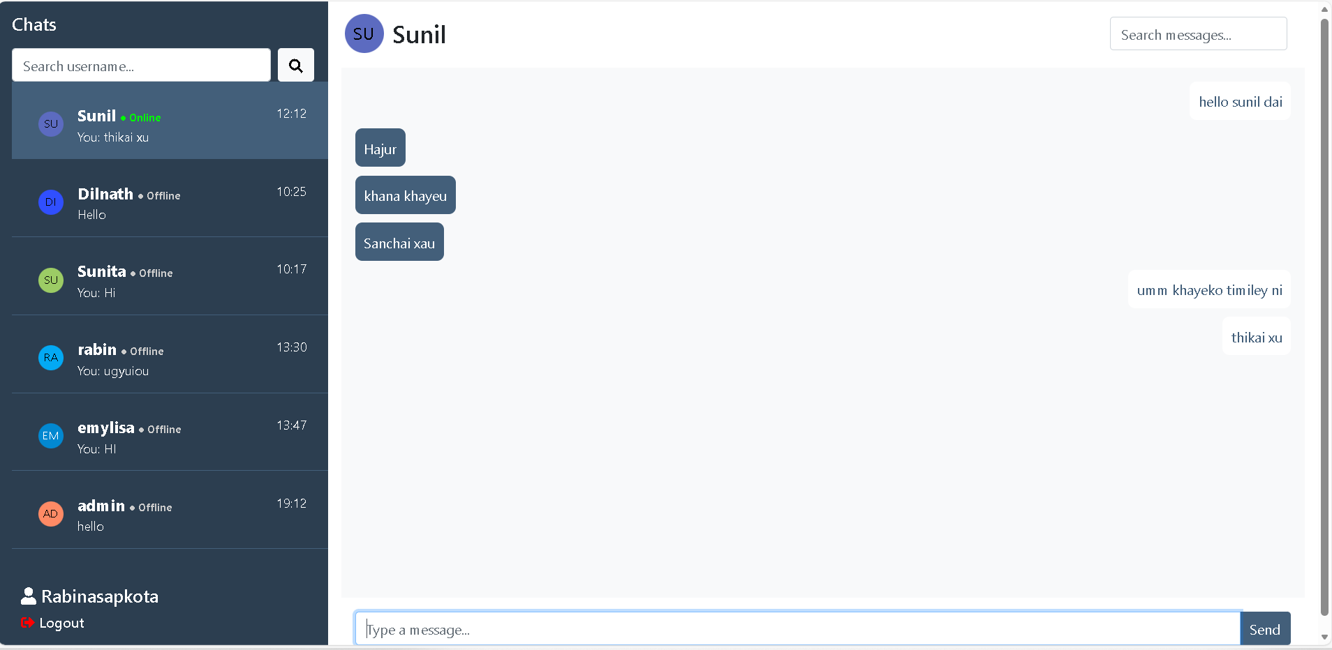

- AES algorithm working:
